**Mushroom Classification Application**

**Wireframe Document**

**Homepage**

**The application is divided into 2 parts:**

**-The homepage**

**-The model**

**1. When we first click the URL, we will be sent to the homepage.**

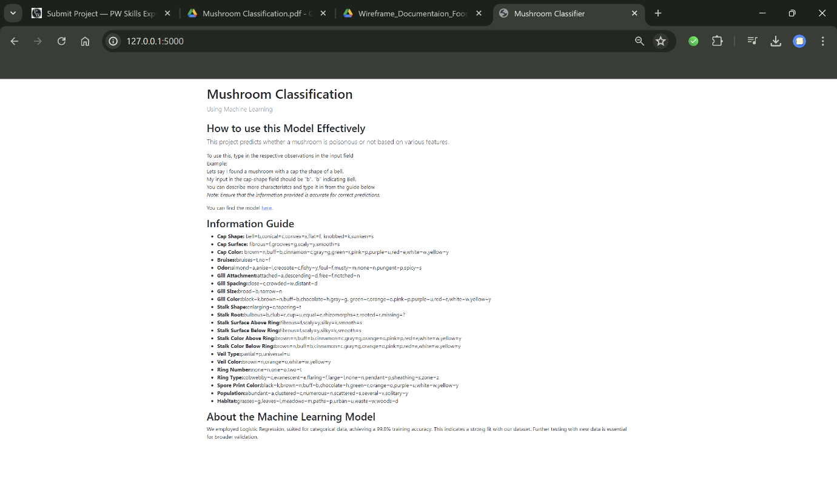

**It contains an introduction to the website, some important abbreviations and some instructions. It also contains the link to our model.**

**2.** 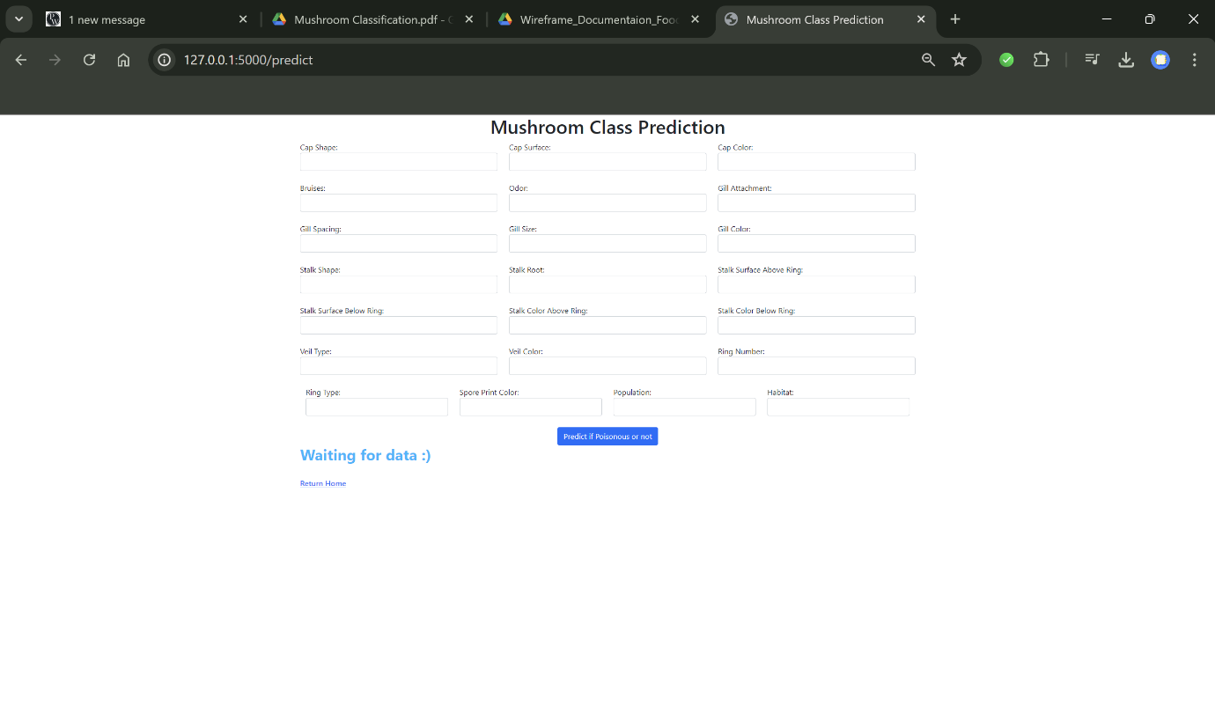

**This is our model page. We see that the model is still expecting an output. We have to start inputting the description of our website**

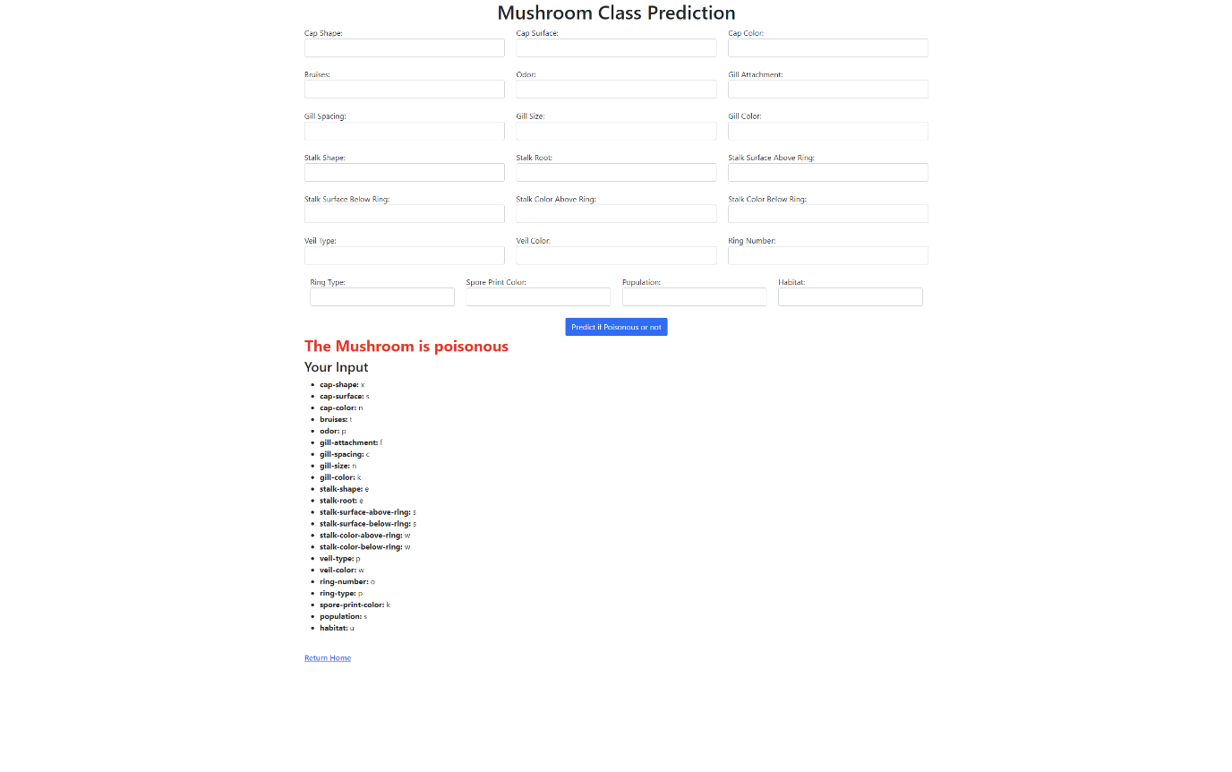

**We get out predicted value and also our input that we had typed.**